***Part 1: Design Research Summary***

**The first method we use: questionnaire(online)**

we both conducted the research

Demographics of people:

1st: 21 years old, Asian, Male. He has a Welsh corgi Pembroke. Location is in His apartment.

2nd: 22 years old, American, female, she has a poodle. Location in her home.

Some data I collected.





Finds from my data collection:

1.dogs like to bite any paper and clothes.

2. Form the report, when their owner stays at home, the dog will stay quiet

3.owner who had a pet for a short time has less experience to treat their crazy.

After, get these finding. Our group thinks we need to hide the paper and clothes and finds some ways to let them not to bit anymore.

**The second method we use: contextual inquiry.**

Jiaohao did the interview with the dog's owner and Ruitong did the observation about record evidences (observer what dogs did when their owner leaves and when their owner accompany with them).

Demographics of people:

1st: 21 years old, Asian, Male. He has a Welsh corgi Pembroke. Location is in His apartment.

2nd: 22 years old, American, female, she has a poodle. Location in her home.

Some data I collected.







**The third method we use: one-to-one interview**

Interviewees：

1st: 21 years old, Asian, Male. He has a domestic shorthair cat. Location is in his apartment.

2nd: 22 years old, Asian, Male. He also has a domestic shorthair cat. Location in his home.

Part of the questions are recorded：

1. Do you have a problem with furniture being destroyed by cat?

1st: No, my cat is inactive and very shy, and she normally only sleeps in my room.

2nd: Yes, my cat is very lively, often in the living room activities, sofa is often damaged.

1. Have you thought about ways to prevent cats from damaging the furniture？

1st: It is not necessary to keep cat from furniture.

2nd: I tried using a spray that the cat doesn't like to spray on the couch to keep the cat from destroying it. But it doesn't work very well.

1. If we design a smart household system, are you interested in trying it out? This product can be uploaded to your mobile phone by the real-time situation of pets.

1st: I don’t think that it’s necessary for me to watch my cat.

2nd: I am interested in this product. Probably, I will try.

Scratches:

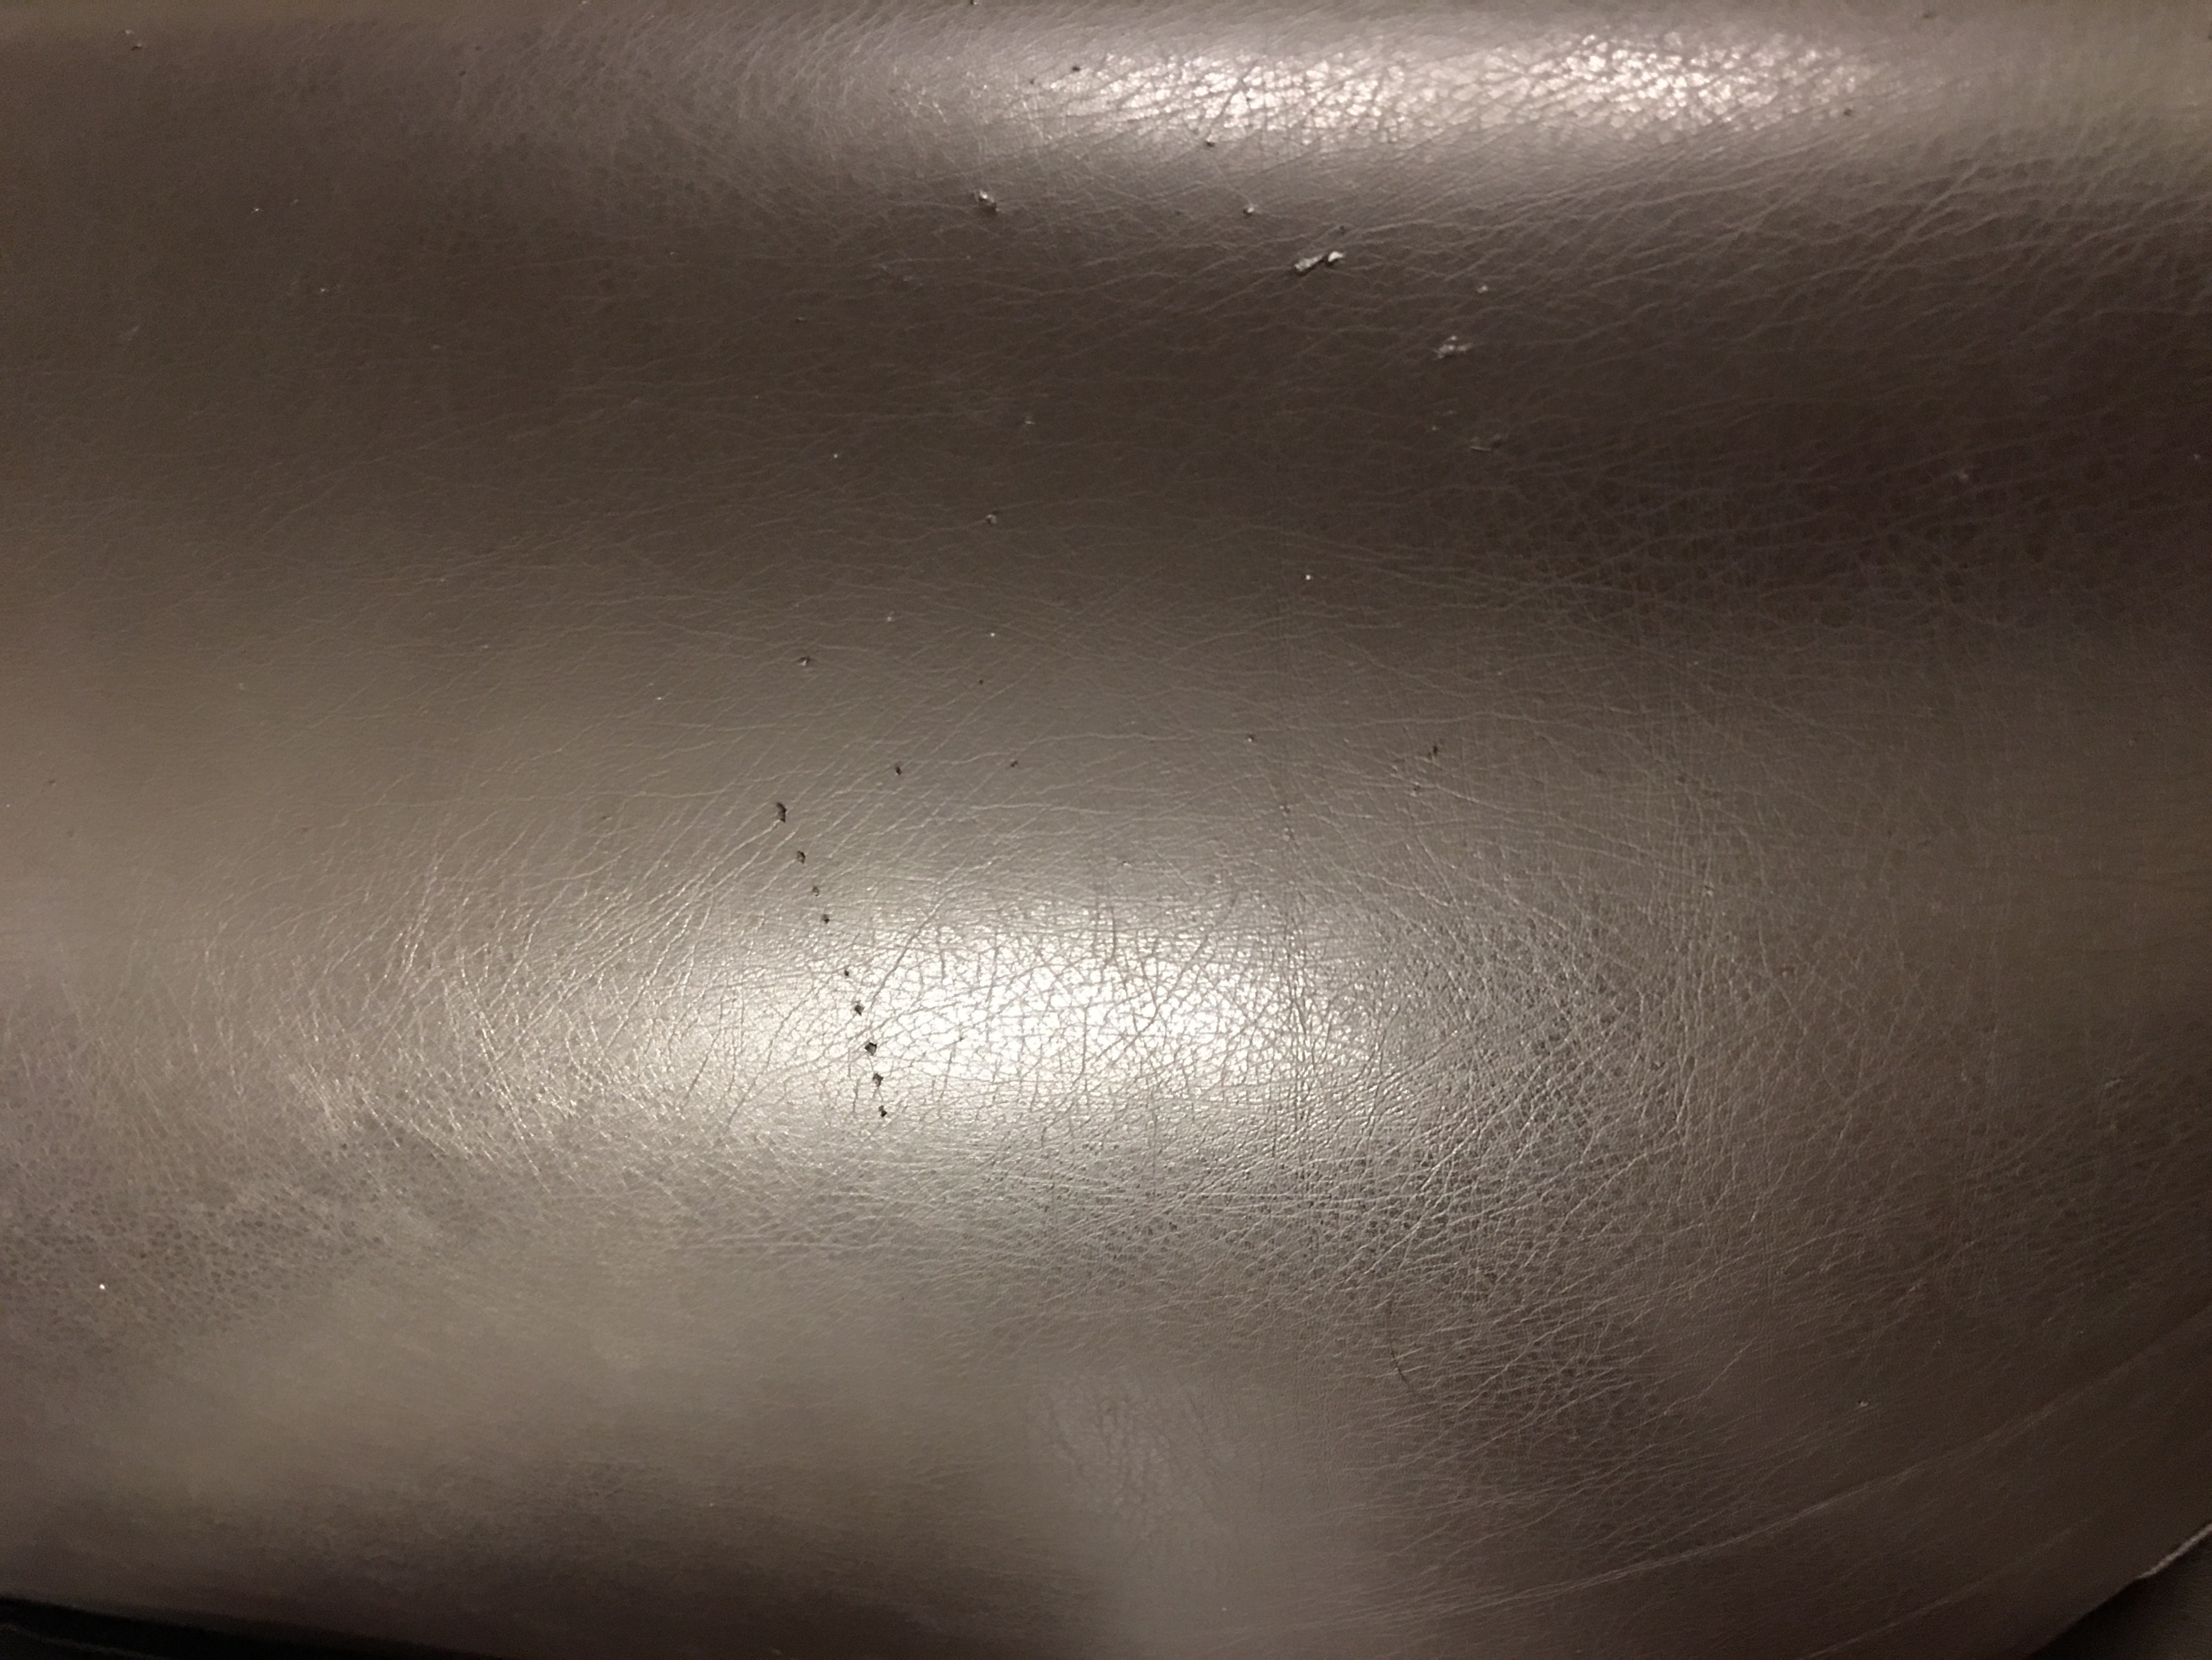

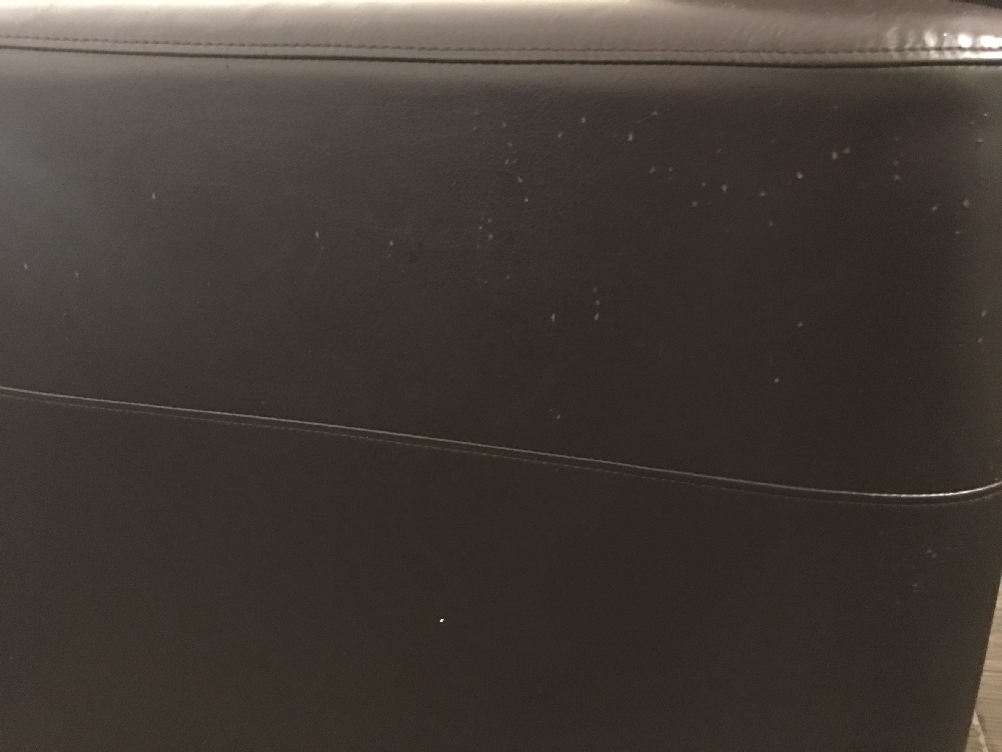

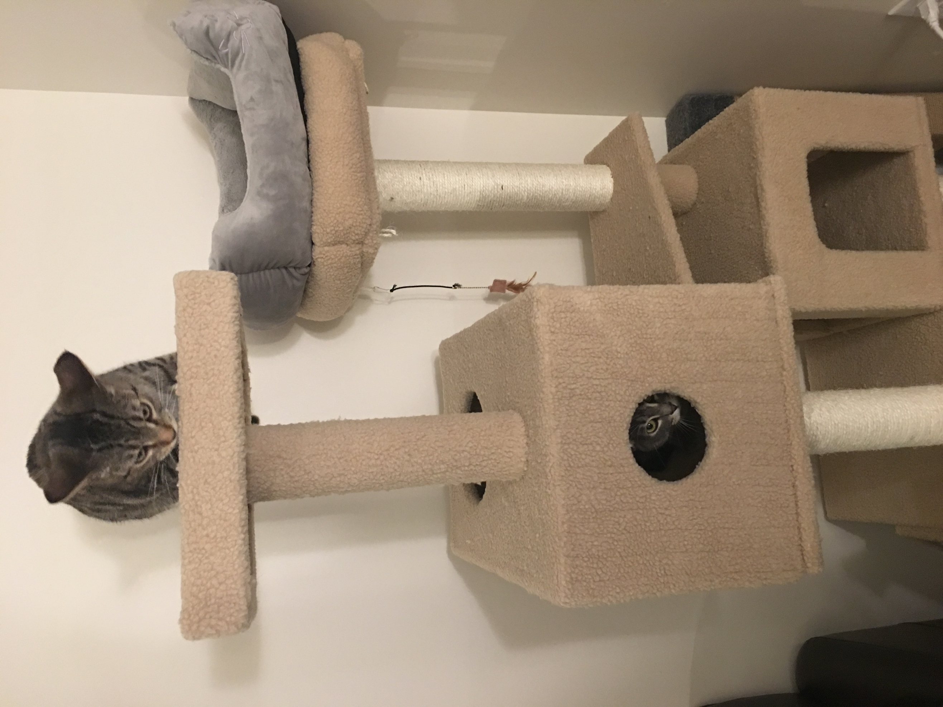

**Finding From our data collection:**

1. When their owners stayed with them, the dog was quiet and performed very well.

2. when they leave dogs start to play.

3. when their owner comes back to home, dog become a mistaken child. stay in a corner. They showed a false expression.

4. Although many pets break furniture, a small number of pets are very obedient and never break furniture. Therefore, we need to find ways to add new features to meet the needs of this part of the customer

**What our group learns is:**

1. We need to Let the dog feel that his director at home. This is a good way to limit dogs.
2. According to different customer requirements, develop new functions that meet the requirements

**Part 2: Group Reflection**

Time: Every night, in our room. Because we are a neighbor.

Jiaohao wang and Ruitong Sun.

we all agree with the findings in part 1

We more agree contextual inquiry is the most useful way. Because the pictures and experience we observed are more impressive than a questionnaire. We emphasize the advantage of contextual inquiry again. At first, the interview we did let us know what the trouble the owner has and then we can do observation more efficient.

And through the video and pictures, recording. We find that if you want your dog to be quiet when you leave, you must produce some voice or odor to convince the dog that its owner still around you.

We think that find a proper way to collect data is more important. We need to master some backgrounds of keeping a dog, but the questionnaire

cannot offer me an impressive image. We not doing statistics. We are preparing an APP. Therefore, finding a proper way is more important.

**Part 3: Appendices**

I mainly interviewed the following questions.

* What's your major?
* When are you away from home and leave pets at home?
* Whether your pet destroys furniture when you're not home?
* Where do you usually keep your pet in your house?
* What is the range of pet activities?
* Have you ever tried to keep a pet in a cage?
* Do your pets often escape from their cages?





